Lab 4- SQLite

Overview
Detective Angela Lansbury, acting director of the UNCC Digital Forensics Lab, has requested assistance in analyzing data extracted from a mobile chat application. The database, pulled using UNCC’s proprietary Mobile Electronics Technical Analysis Lab (METAL) platform, is believed to hold communication records involving Rett Harring, a known associate of high-profile criminal figures. Initial parsing attempts by the lab technician were unsuccessful, prompting my involvement to examine the SQLite database and uncover key evidence on Harring’s interactions and potential involvement in recent thefts.
The forensic examination was performed on a Dell Inspiron laptop running Windows 11. The system specifications are as follows:
- Device Model: Dell Inspiron
- Processor: Intel Core i7-1165G7 @ 2.80GHz
- RAM: 16 GB
- Storage: 512 GB SSD
- Operating System: Windows 11 Home 64-bit
The primary analysis tool used was SQLiteStudio v3.4.4, a lightweight, open-source platform for interacting with SQLite databases.
To initiate the forensic review, the following steps were carried out:
- SQLiteStudio Setup:
SQLiteStudio was downloaded and extracted directly to the system. As the tool is portable, no installation was necessary.
- Loading the Database:
  - The application was launched.
  - From the menu, Database > Add a database was selected.
  - The ChattyMcChatfaceChats.db file was located and added.
  - The database loaded successfully, revealing multiple tables including Zmsgs, zContacts, and zConstants.
- Initial Examination:
  - Tables were browsed through the Data tab for visual inspection.
  - Specific queries were executed through the SQL Editor to extract relevant messages, timestamps, encoded data, and contact information.

Question 1:
What was the date of contact for the user who replied, "Nu phone who dis"?
Using SQLiteStudio, I navigated to Zmsgs under the ChattyMcChatfaceChats database and located the message “Nu phone who dis” by filtering the data in the text column. The corresponding timestamp listed for this message was 1588990423.
To convert this epoch timestamp into a readable format, I used an online Epoch to Human Date converter. The result provided the following:
- UTC Time: Saturday, May 9, 2020, at 2:13:43 AM
- Local Time (GMT-7, DST): Friday, May 8, 2020, at 7:13:43 PM
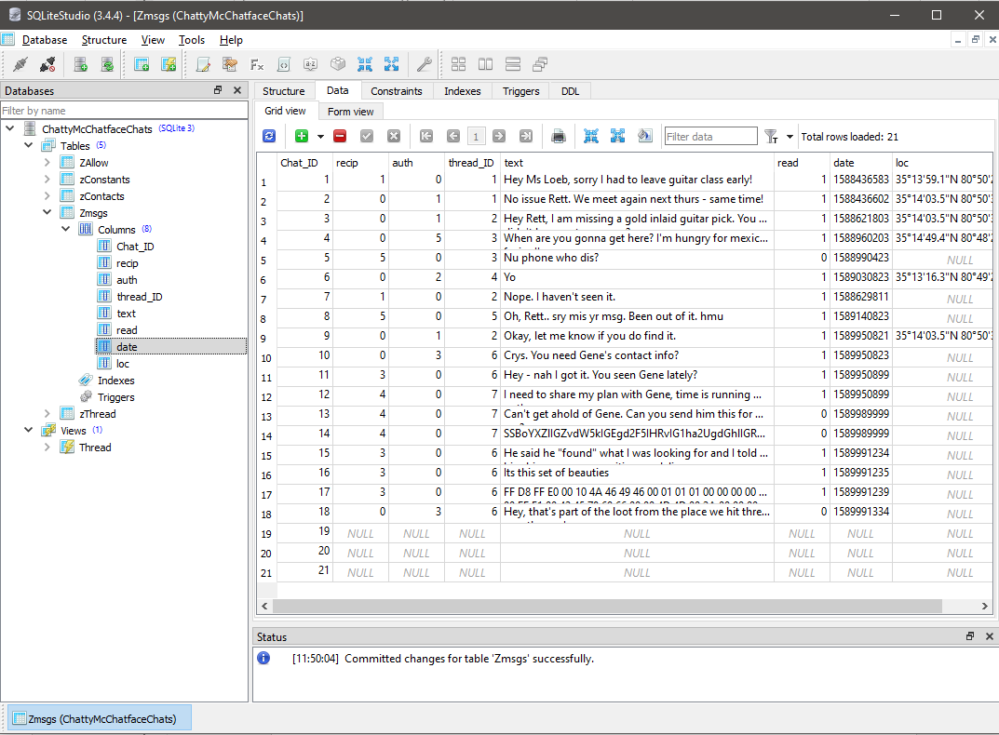
- Relative Time: Approximately 4 years ago

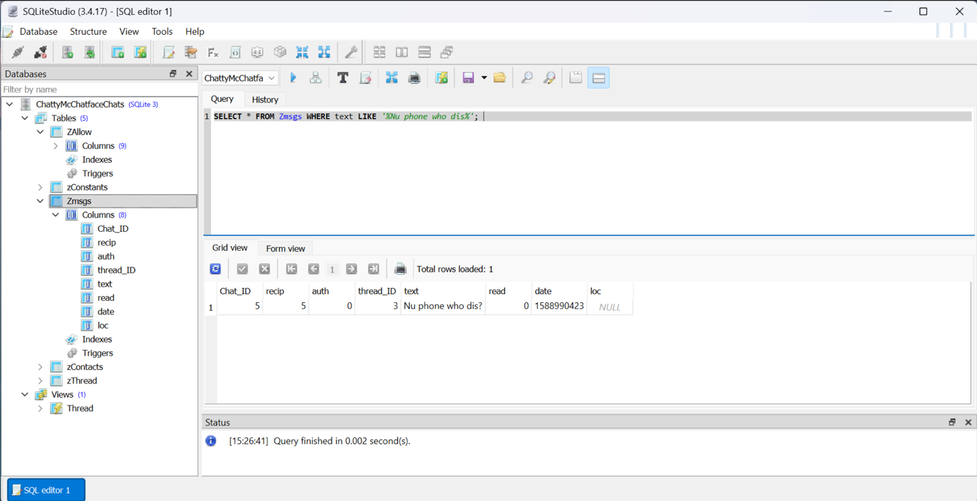
Question 2:
Which users (by their email) were involved in that conversation?
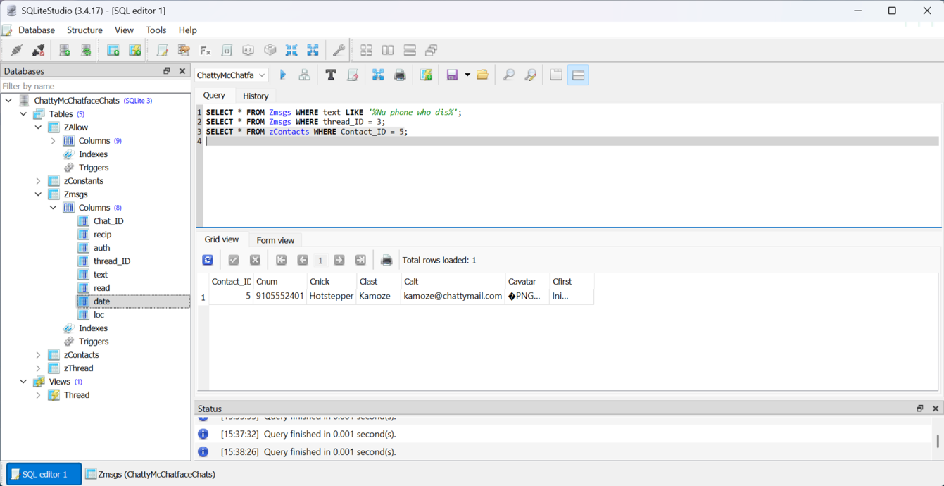
To identify the participants in the conversation containing the message “Nu phone who dis,” I examined the Zmsgs table within the ChattyMcChatfaceChats database. The message was part of thread_ID 3, which includes two entries: one from user ID 0 and the other from user ID 5.By referencing the zContacts table and matching Contact_ID 5, I determined the user is Ini Kamoze, with the email address kamoze@chattymail.com. The user with ID 0 is not listed in the contacts table, which strongly indicates that this ID belongs to Rett Harring, using the email rett.harring@outlook.com.
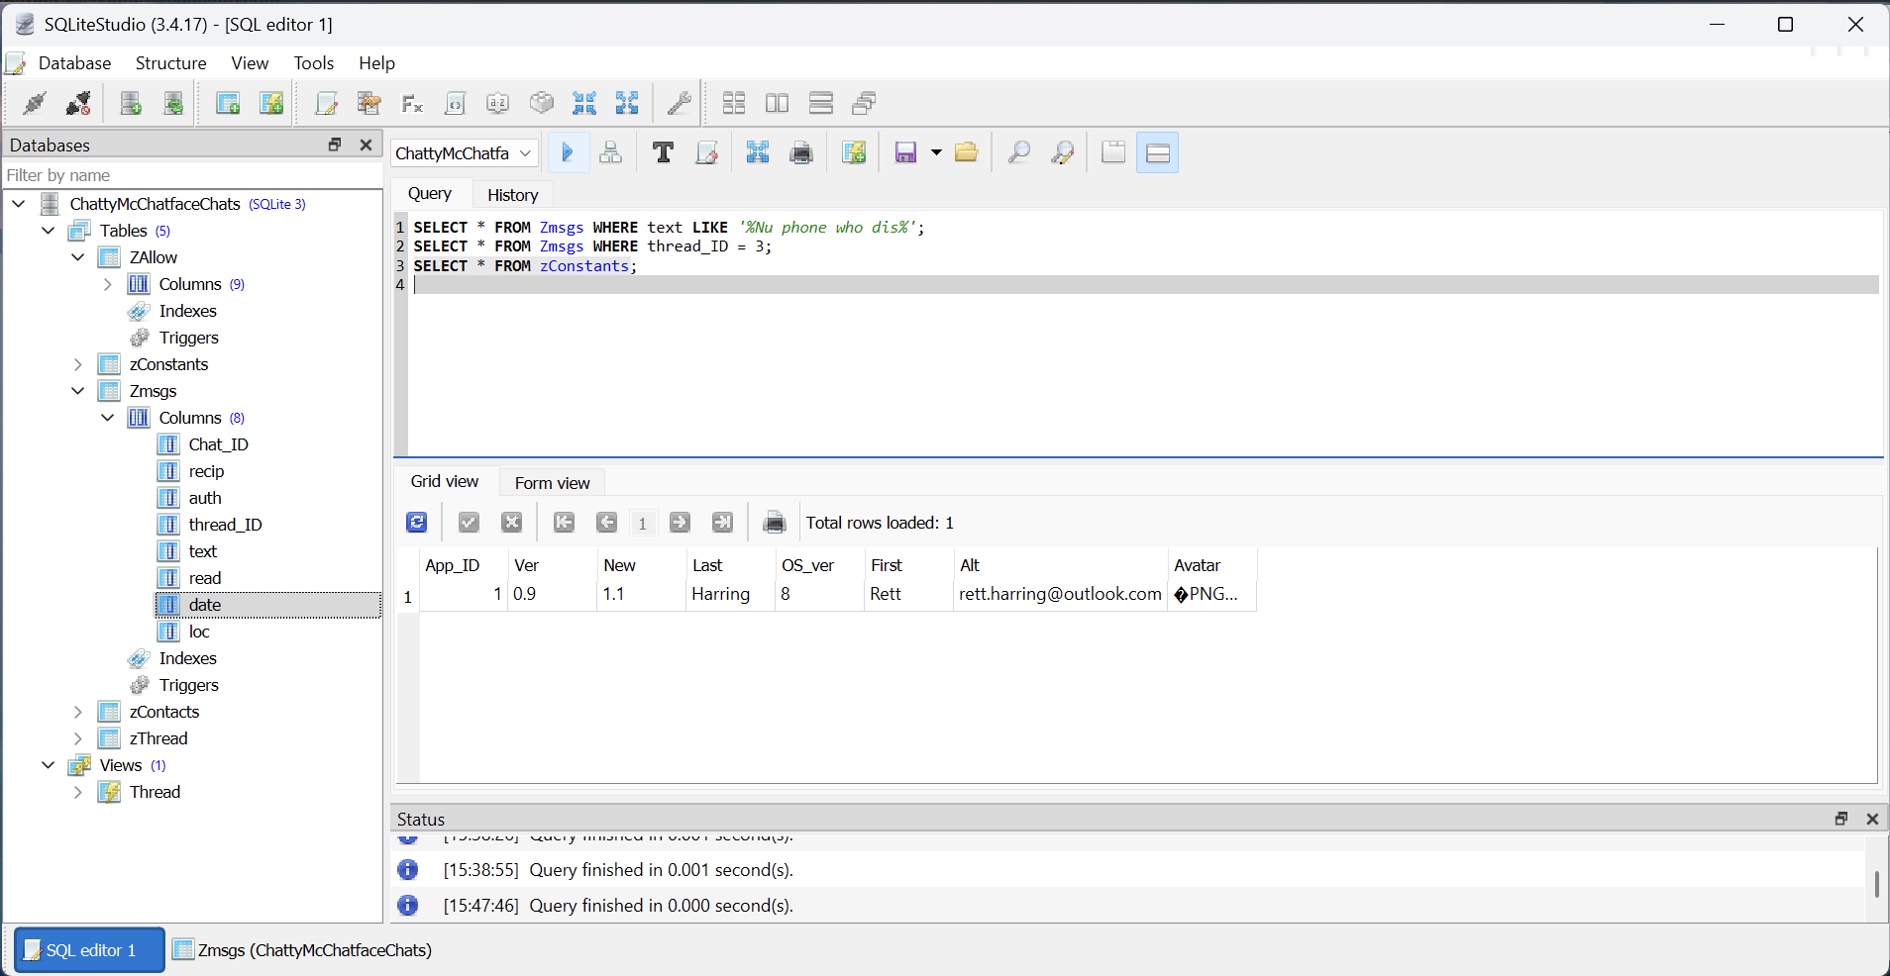
Question 3:
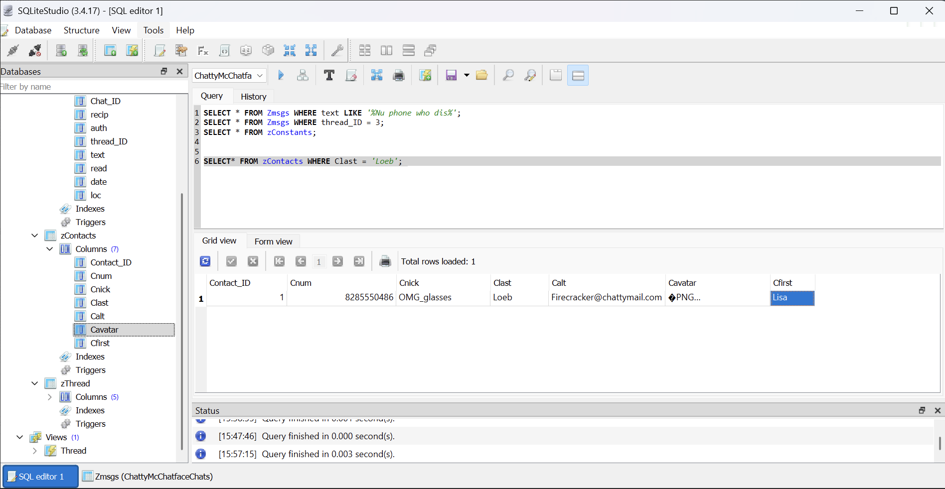
What does Ms. Loeb look like?
Ms. Lisa Loeb’s contact profile and image can be found in the zContacts table within the ChattyMcChatfaceChatsdatabase. By examining the Cavatar column, which stores contact avatars in binary format, we can locate her visual ID.Her entry lists her with the nickname "OMG_glasses", and the corresponding image reveals her wearing dark-rimmed glasses, a striped shirt, and smiling in front of a soft-toned background, consistent with her quirky alias.
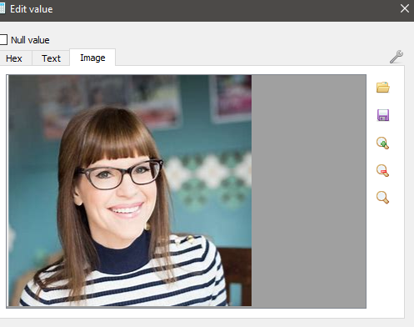
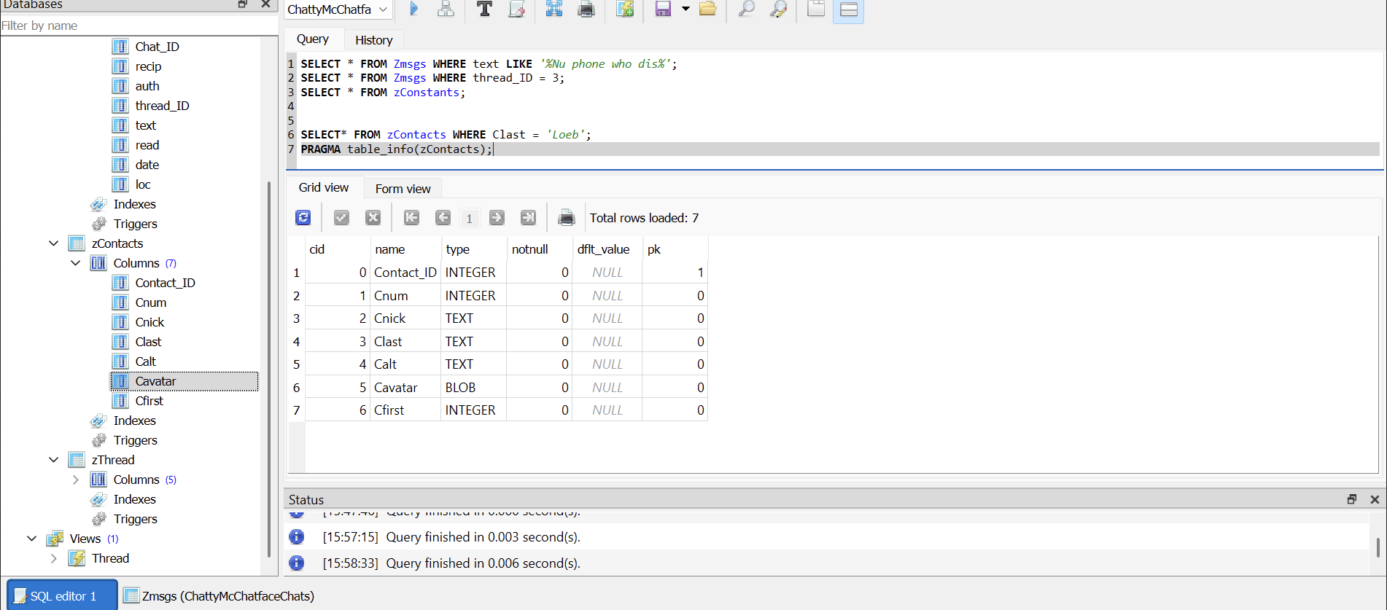

Question 4:
What item appears to have been stolen and when was the message sent?
An item believed to be stolen is referenced in a message found within the Zmsgs table of the ChattyMcChatfaceChatsdatabase. The message includes a hexadecimal string that, when analyzed, suggests the item resembles a pair of jars.
The hexadecimal data was extracted by locating the relevant entry in the text column and was subsequently decoded using a hex-to-image converter, and the corresponding message has a UNIX timestamp of 1589991239, which, when converted, gives the following details:
- UTC: Wednesday, May 20, 2020 at 4:13:59 PM
- Local Time (GMT-07:00 DST): Wednesday, May 20, 2020 at 9:13:59 AM
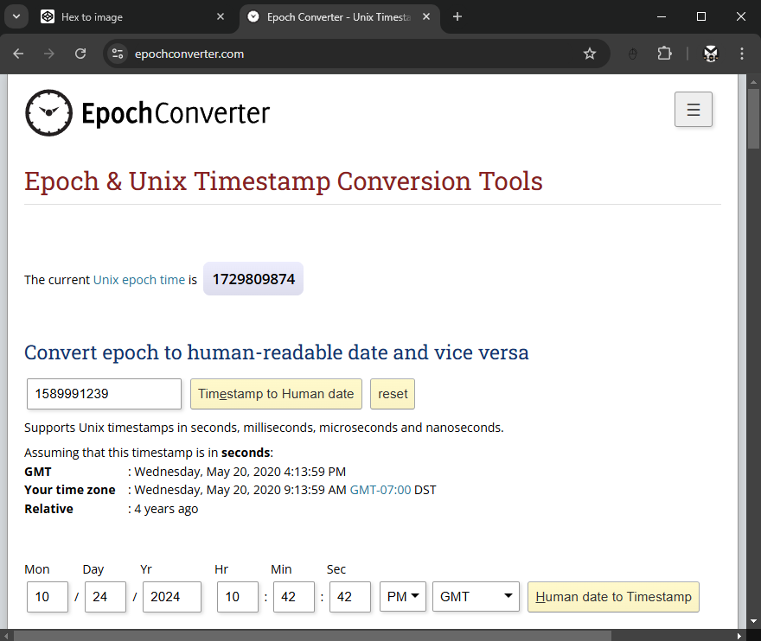
- Relative Time: Approximately 4 years ago

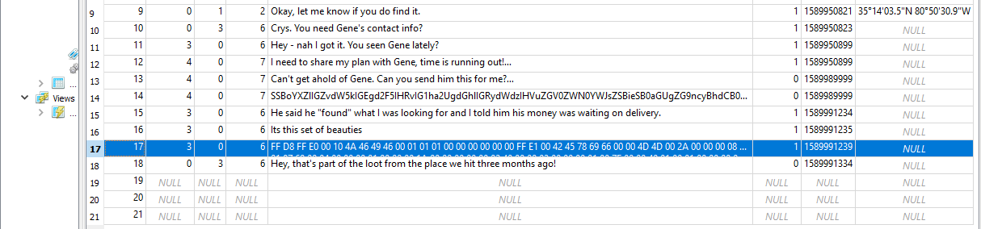

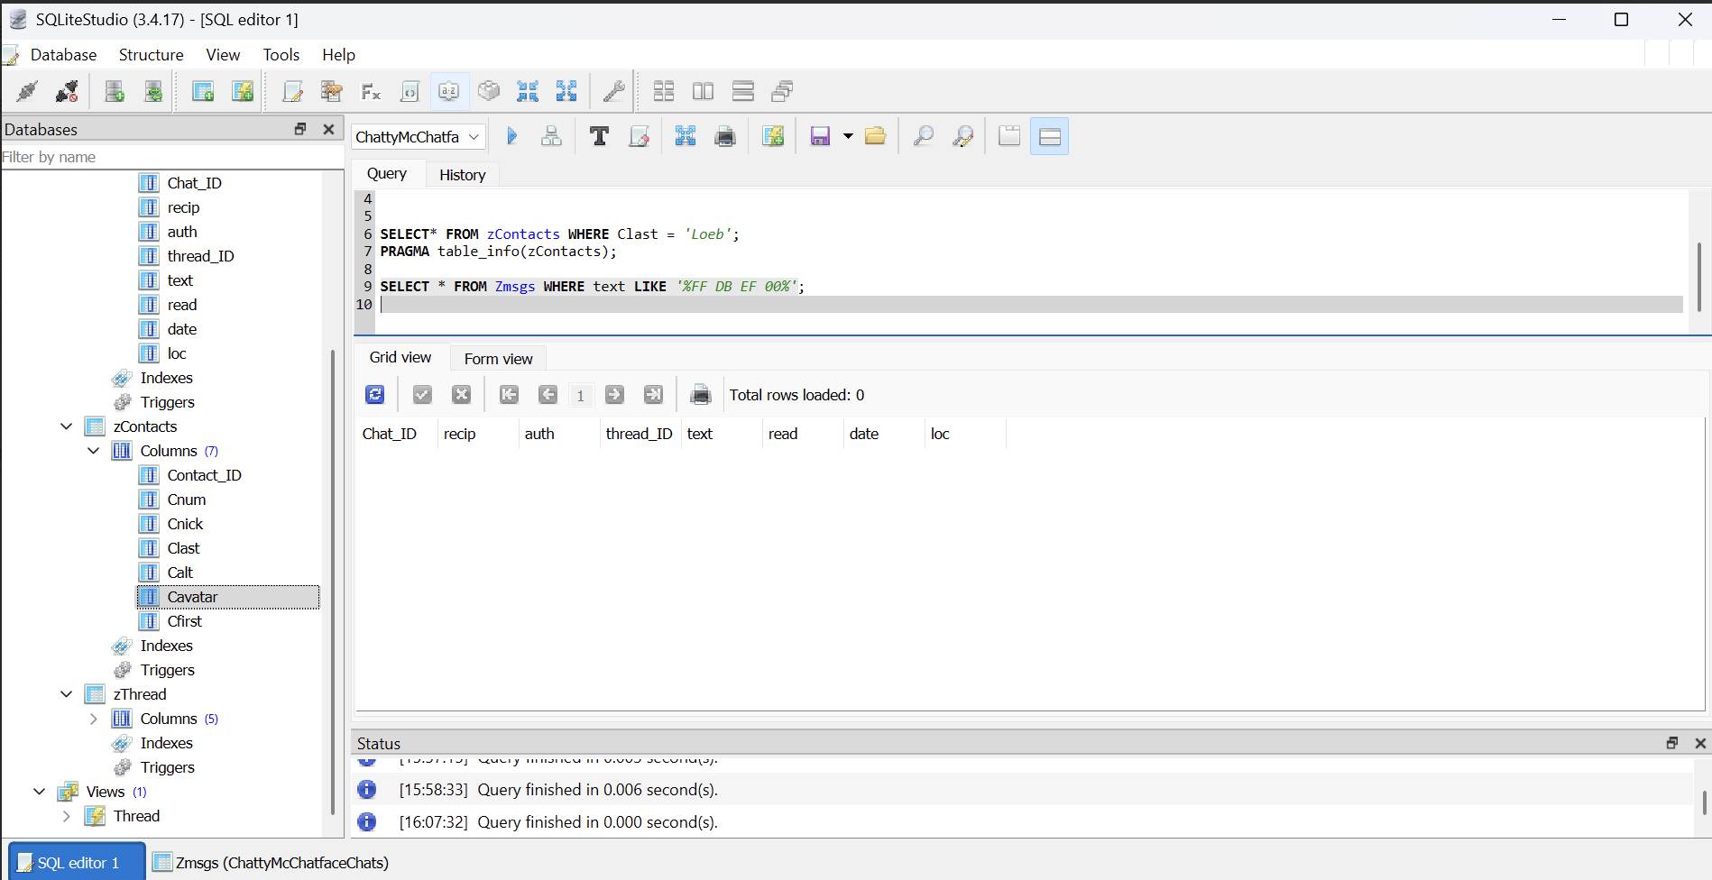
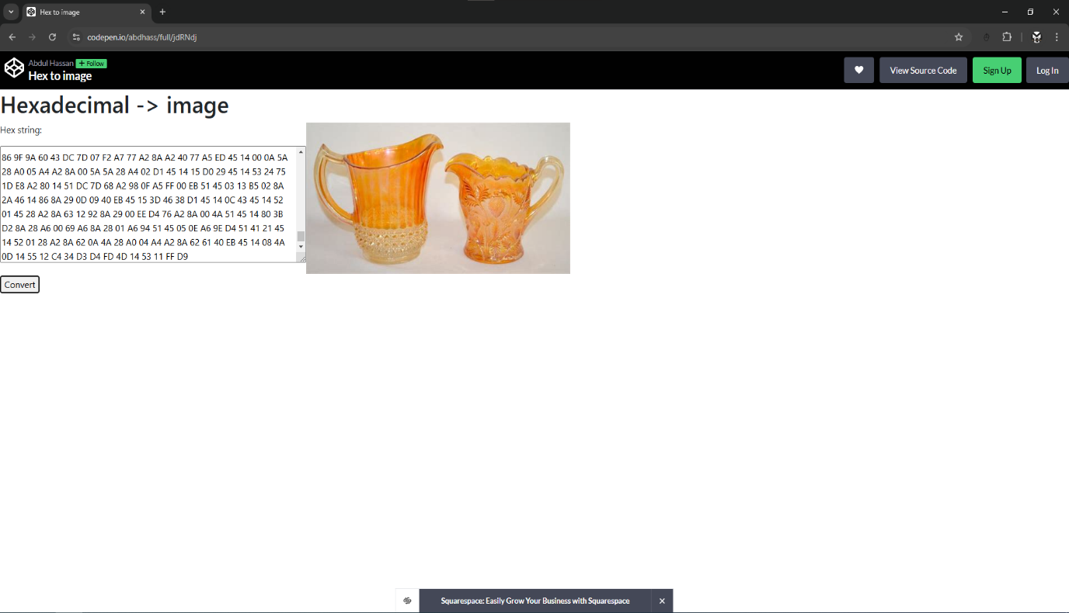
Question 5:
Who has Rett sent messages to most often (email)?
To determine which contact received the most messages from Rett Harring, I queried the Zmsgs table in the ChattyMcChatfaceChats database. Messages where Rett is the sender (identified by auth = 0) were filtered and grouped by recipient ID (recip) to calculate message frequency.
The results showed that Rett most frequently sent messages to two contacts:
- Crystal Waters (OneZeroZeroPct@chattymail.com)
- Stuart Goddard (TwoShoes@chattymail.com)
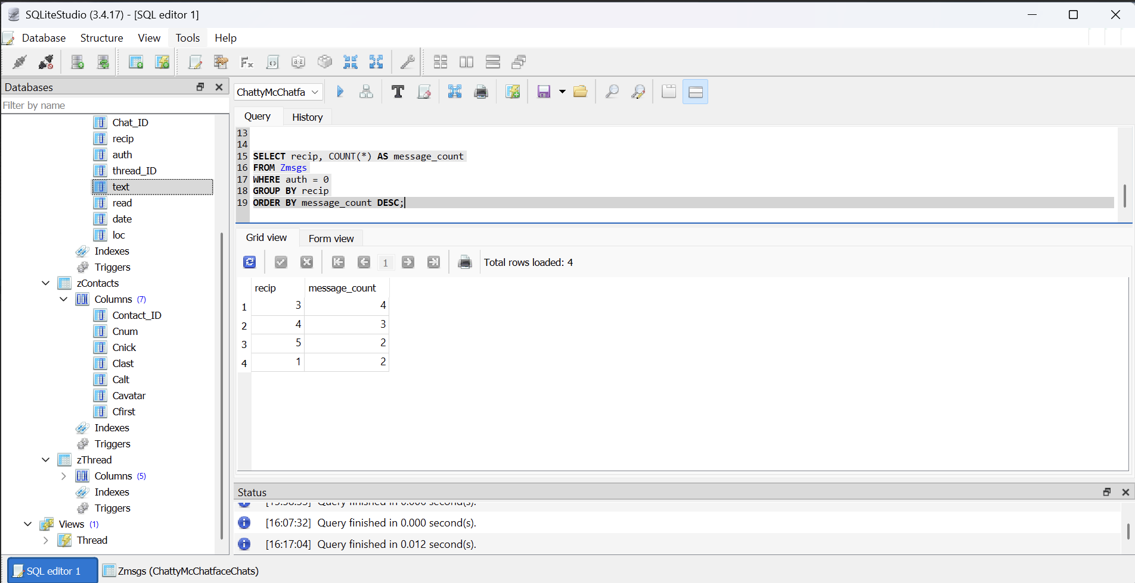
This conclusion was supported by matching the recipient IDs from Zmsgs to the corresponding entries in the zContactstable using the Contact_ID field.
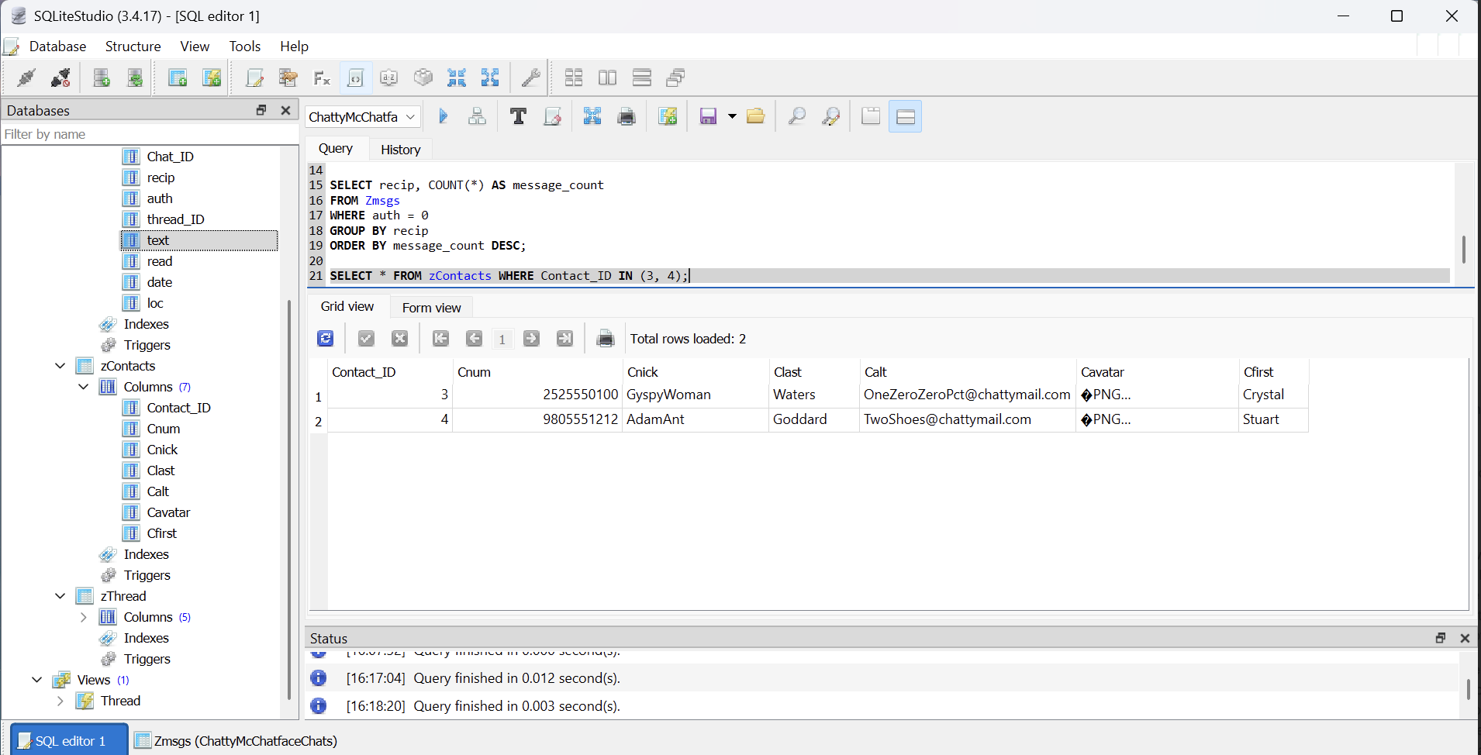
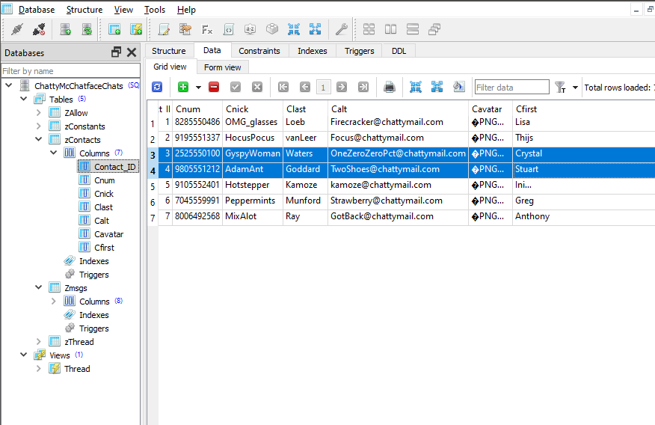

Bonus:
Can you tell what the text was in the secret message?
A Base64-encoded string was found embedded in one of the messages in the Zmsgs table. Upon decoding, the hidden message revealed an alarming detail about circumventing drug detection. This hidden text provides insight into potentially illegal activities Rett may be involved in.
Decoded Secret Message:
“I have found a way to make the drugs undetectable by the dogs at the checkpoint. It’s my own special mix of sage, rosemary, thyme, VapoRub, and Carolina reaper oil!”
Method used to decode : The encoded data can be decoded using a Base64 decoder.

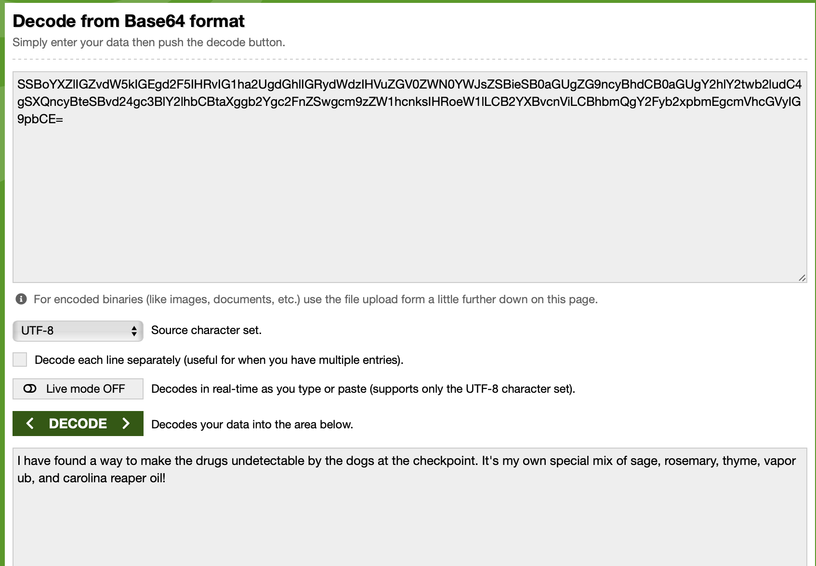
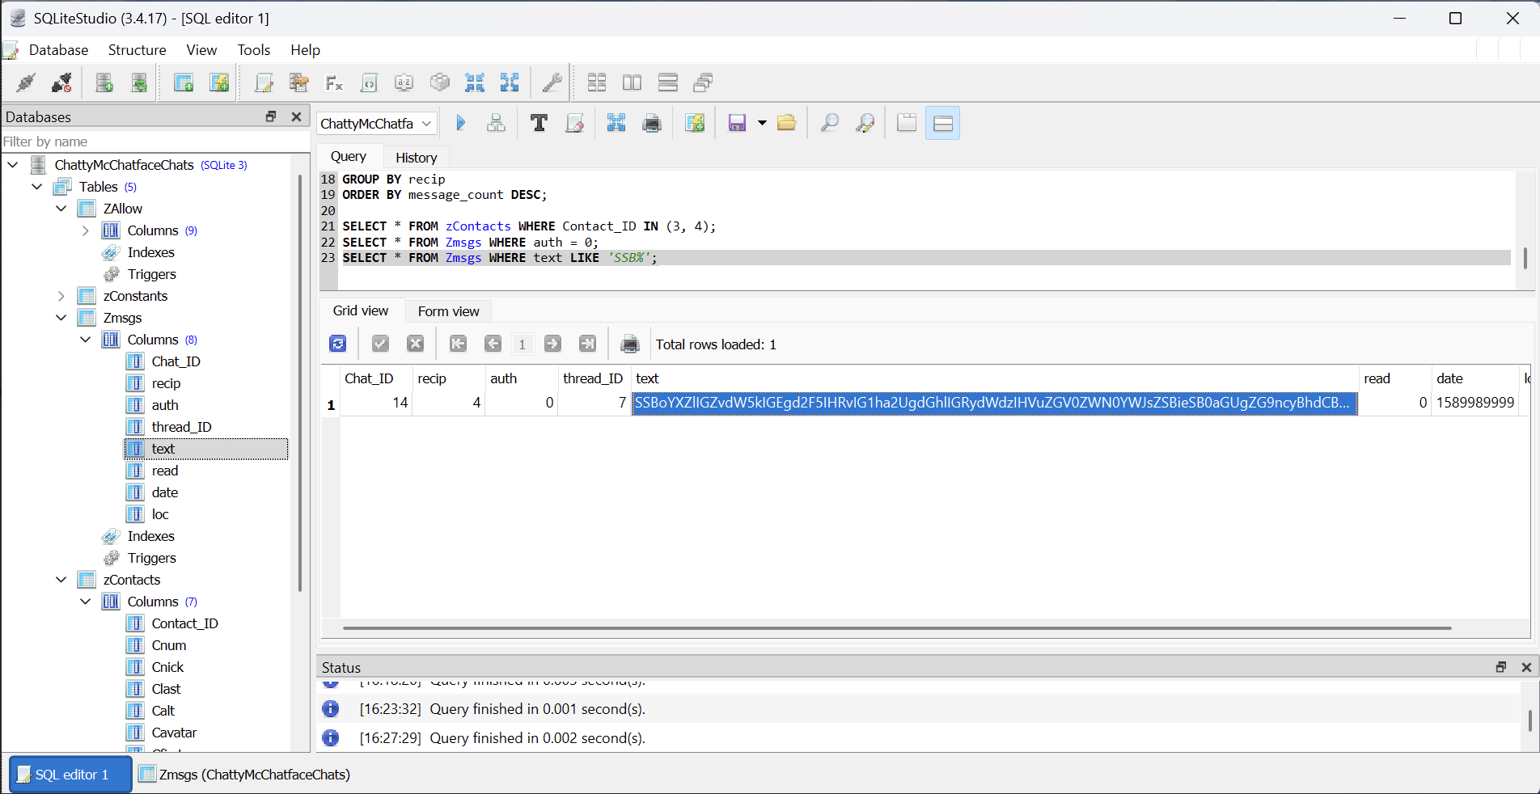

Conclusion
As part of the forensic investigation led by Detective Lansbury, this analysis successfully uncovered communication patterns involving Rett Harring and several key contacts. Using SQLiteStudio, messages were examined to identify frequent recipients, decoded image and text-based evidence, and retrieved user profiles including images and email addresses.
Significant findings include:
- Conversations with Crystal Waters and Stuart Goddard, Rett’s most frequent contacts.
- A hidden image resembling stolen jars, decoded from hexadecimal format.
- A Base64-encoded message revealing a suspicious method for evading drug detection.
All evidence has been compiled into this report and submitted for review, alongside supporting screenshots and decoded artifacts.

